Youth Protection Training:
- Go to myscouting.scouting.org
- Click on “create an account”
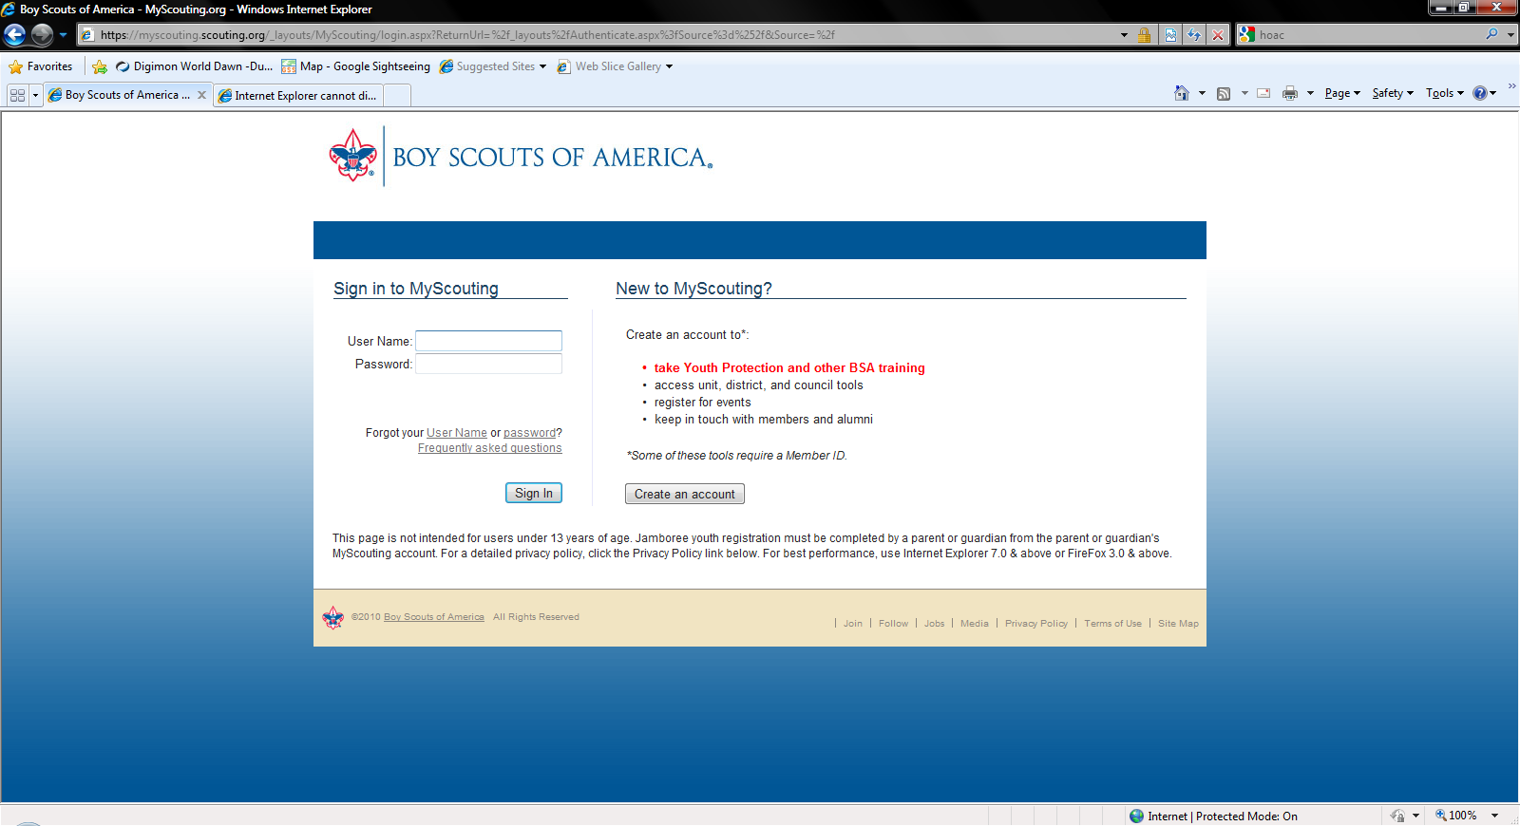
- Enter a user name and click “check user name availability”
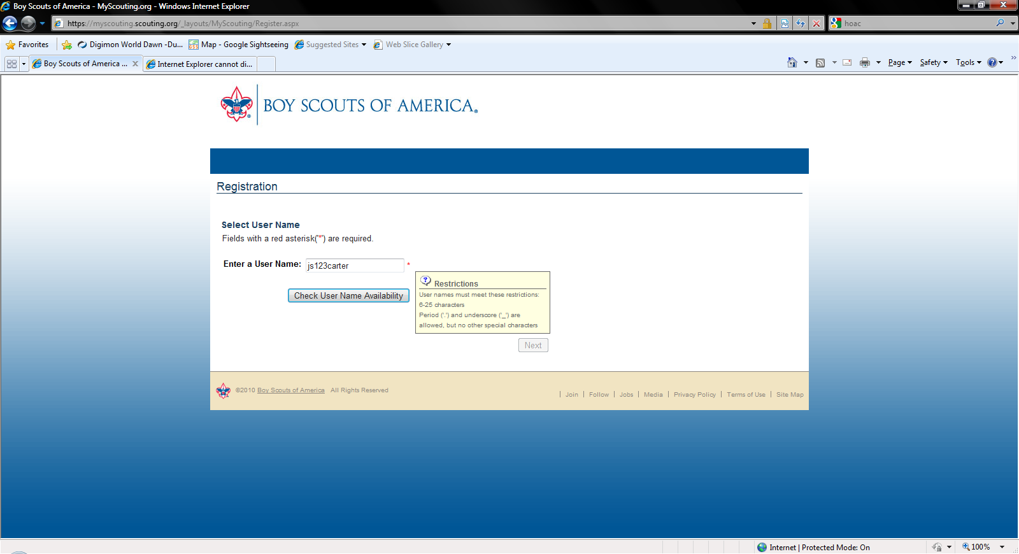

- If the user name is available, a message appears. Click “Next”
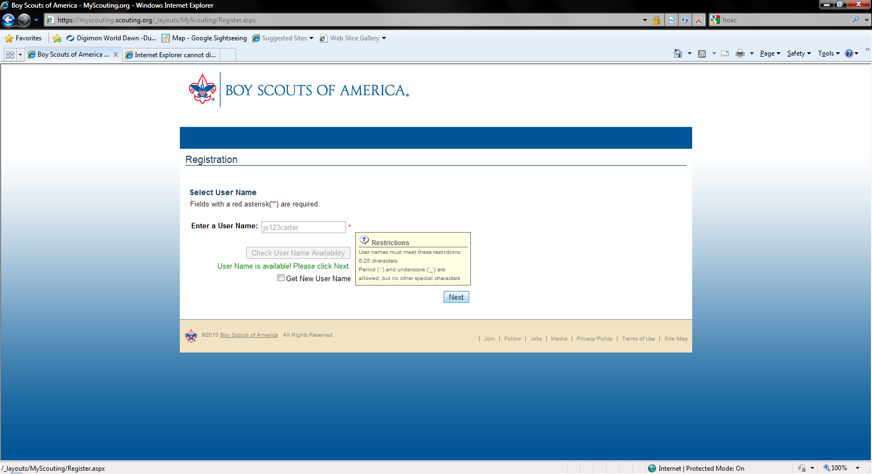
- Select the “I am new…… “ option and click “next”
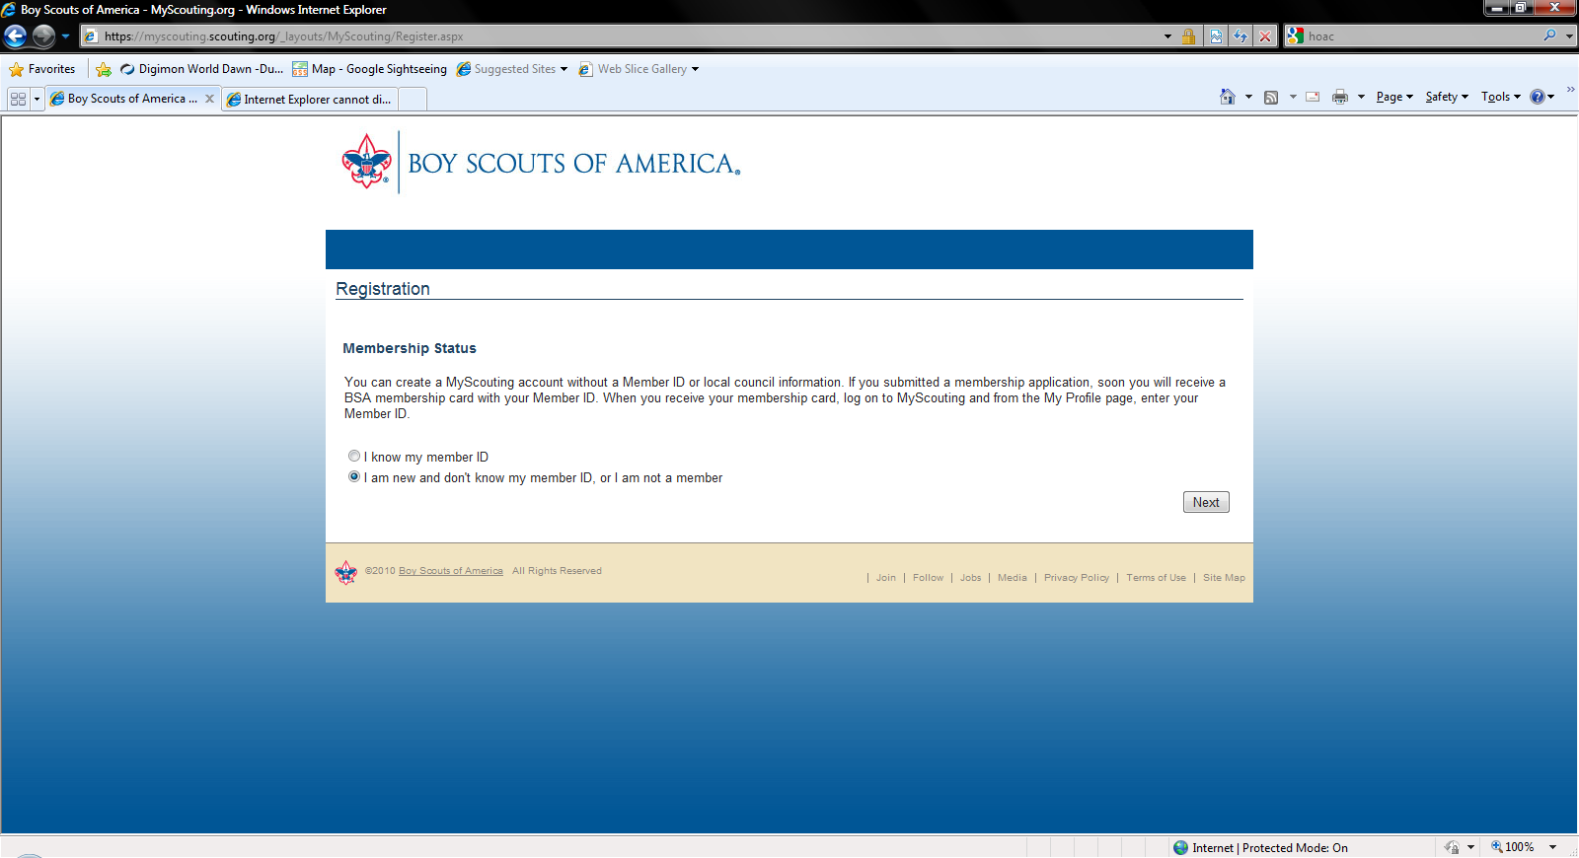

- Enter the required information, select the “I accept these terms & conditions”, Enter the “verification” code letters, and click “create user”
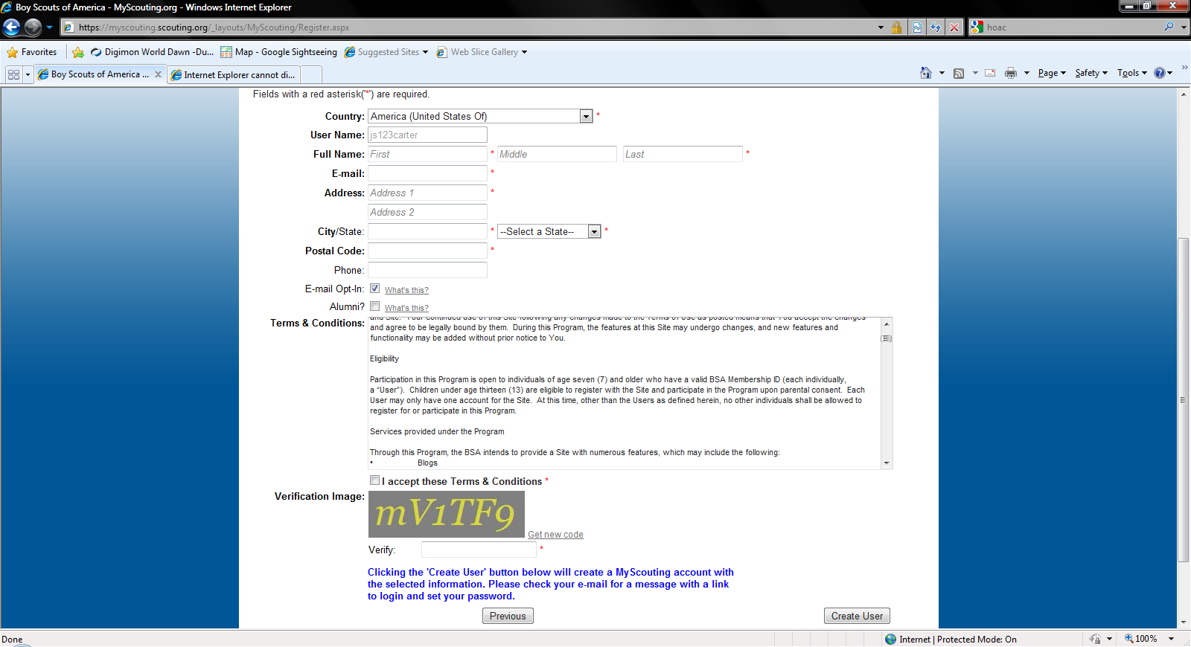
- Choose your security questions, type in your answers, and click “ok”
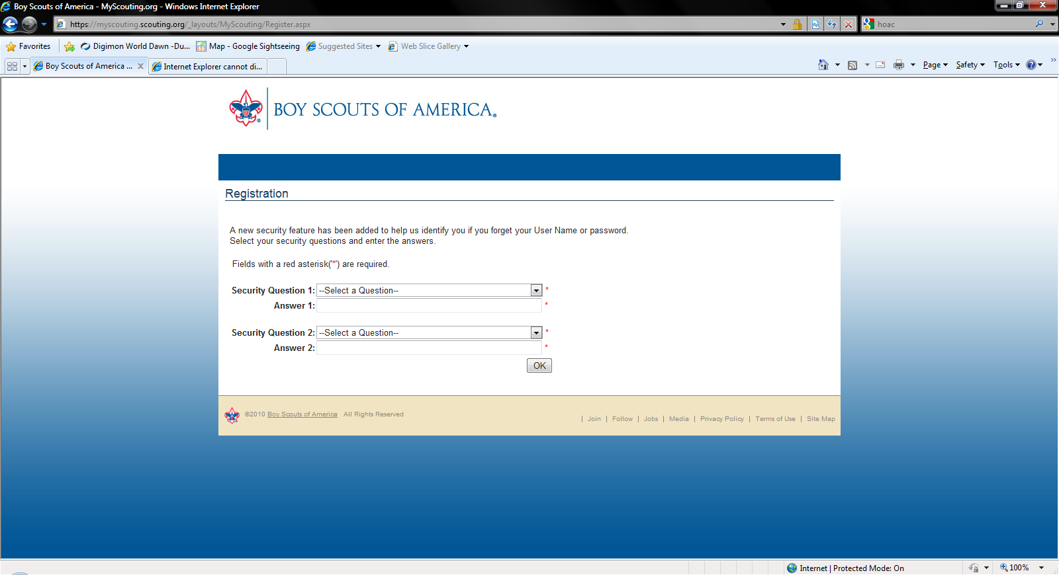

- Click “continue” on the next screen.
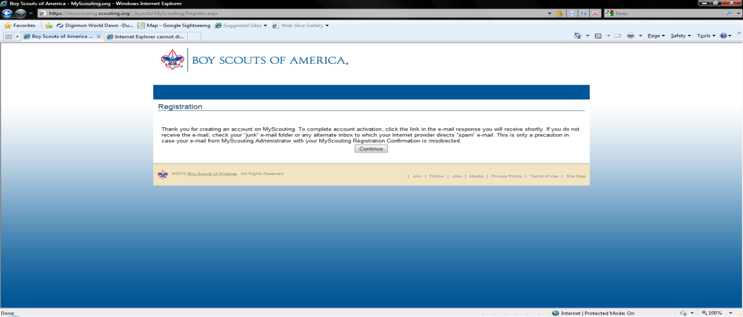
- You will be at the sign in page. Enter your user id and click on the “forgot password” link, answer your security questions, choose your password, then click “ok”. This will return you to the “sign-in page”. Enter your id/password and log in.
- Click on the “e-learning” link on the navigation area on the left side of the screen.
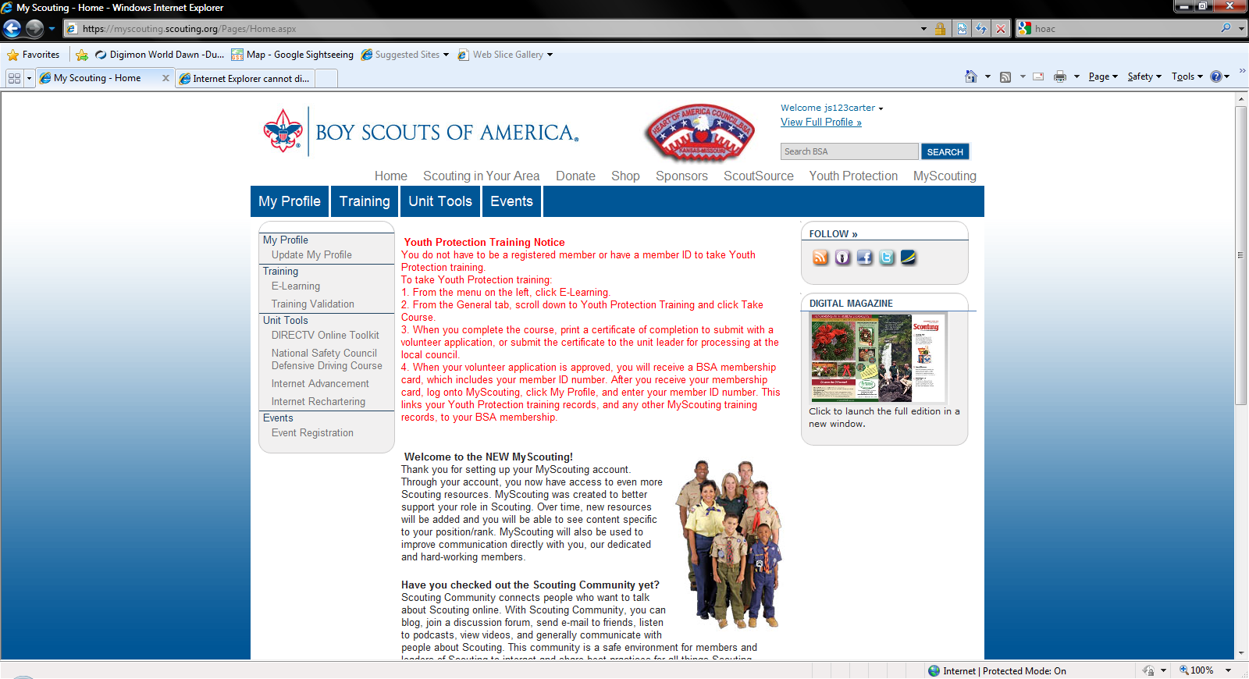

- Click on the “take course” link, next to Youth Protection.
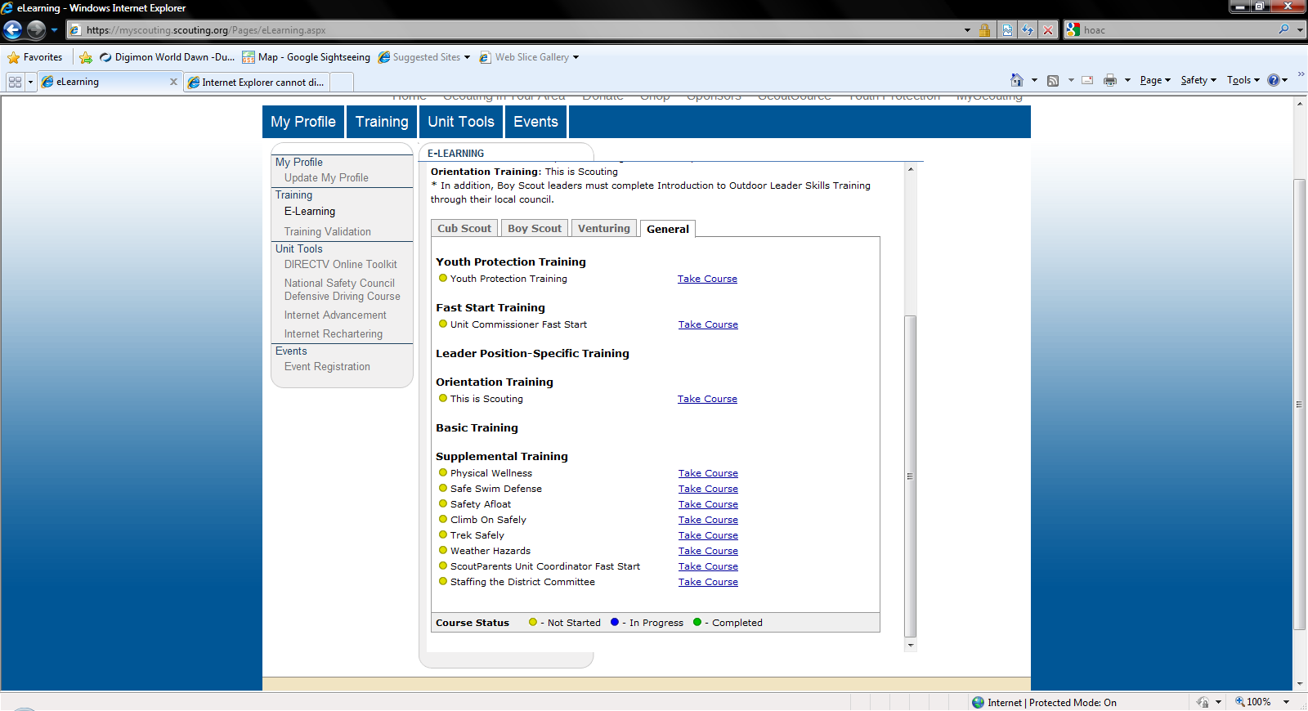
- When you complete the training, PRINT OFF YOUR CERTIFICATE and bring it to the first den meeting, on Sept 13th.
**** ADDITIONAL TRAINING REQUIREMENTS FOR DEN LEADERS/ASSISTANT DEN LEADERS!!!
In addition to youth protection, you will need to take the “DEN LEADER FAST START”, “LEADER POSITION – SPECIFIC TRAINING (choose only the training specific to your den level), and last but not least…. “THIS IS SCOUTING”.
Note: This is scouting is a video based training, that you cannot “fast forward” through. Allow about 30-45 minutes to complete it.
PRINT OFF ALL TRAINING CERTIFICATES AND BRING THEM TO THE MEETING ON THE 13th.

I should add that youth protection is required every 2 years and the other training is a “one-time-only” deal.

